**US03 – People manager Overview**

## **Short description**

**In order to** manage communication moments

**As a** PM

**I want to** have an overview that displays MY moments + those of all people in my team

## **Detailed description**

The tool requires confirmation by both parties in the conversation for it to be ‘accepted’. Hence the **PM** will need to confirm the conversations (s)he’s had with all people in his/her team. To accommodate for this on the overview page, we would first like to show his/her personal conversation moments (with the portfolio manager).

Underneath the personal moments, all the moments of every team member (based on active directory) should be visible, listed alphabetically (name should also be visible). It would have to look like this:

1. PM
   1. Team member (non-collapsible, all team members are always shown)
   2. Team member

Both the personal and the team conversation moments should function as the personal moments as explained in US02.

On another level we want to add the **portfolio manager** as well. So the structure would look as follows:

1. Portfolio manager
   1. PM (collapsible, if opened all team members shown - so not collapsible on team member level)
      1. Team member
      2. Team member
   2. PM
   3. PM

**Mockups**

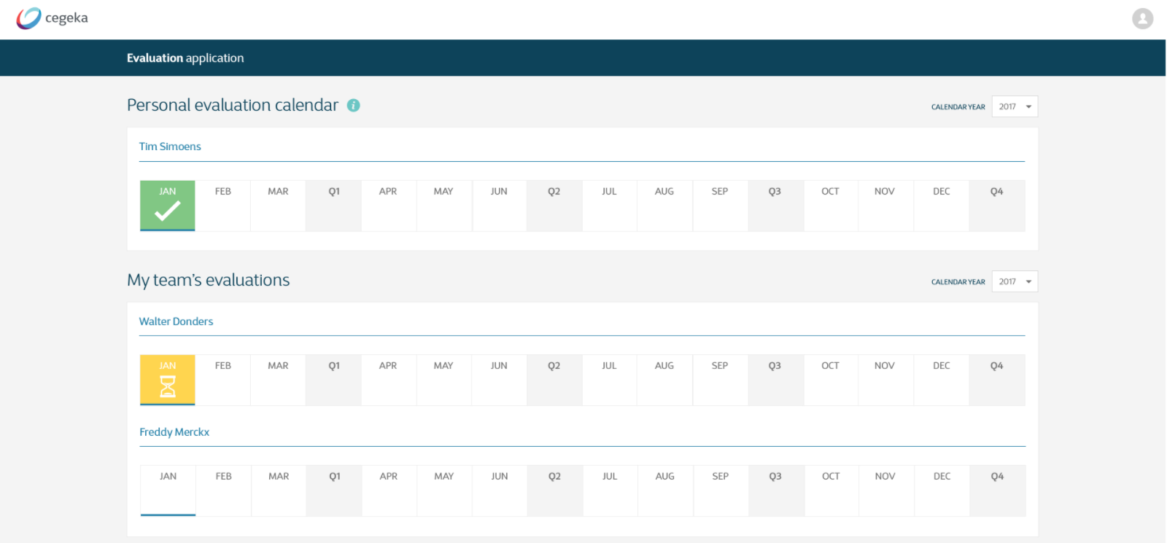

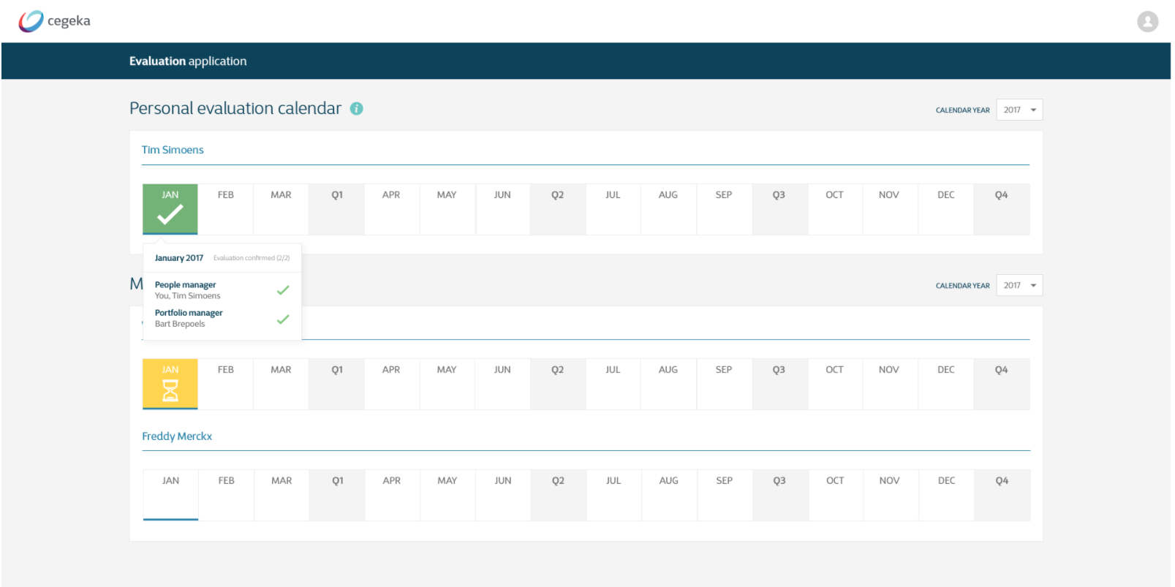

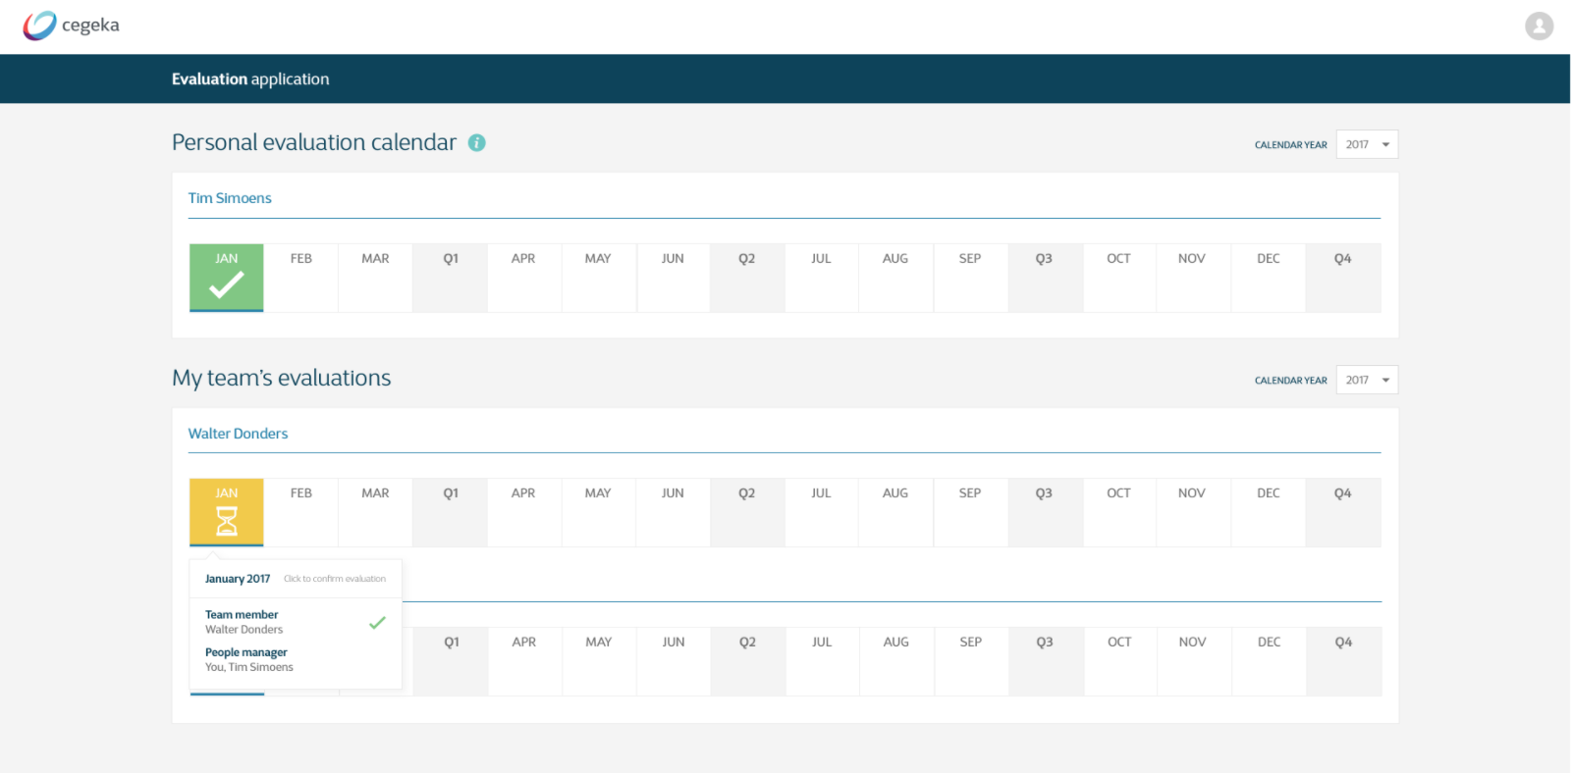

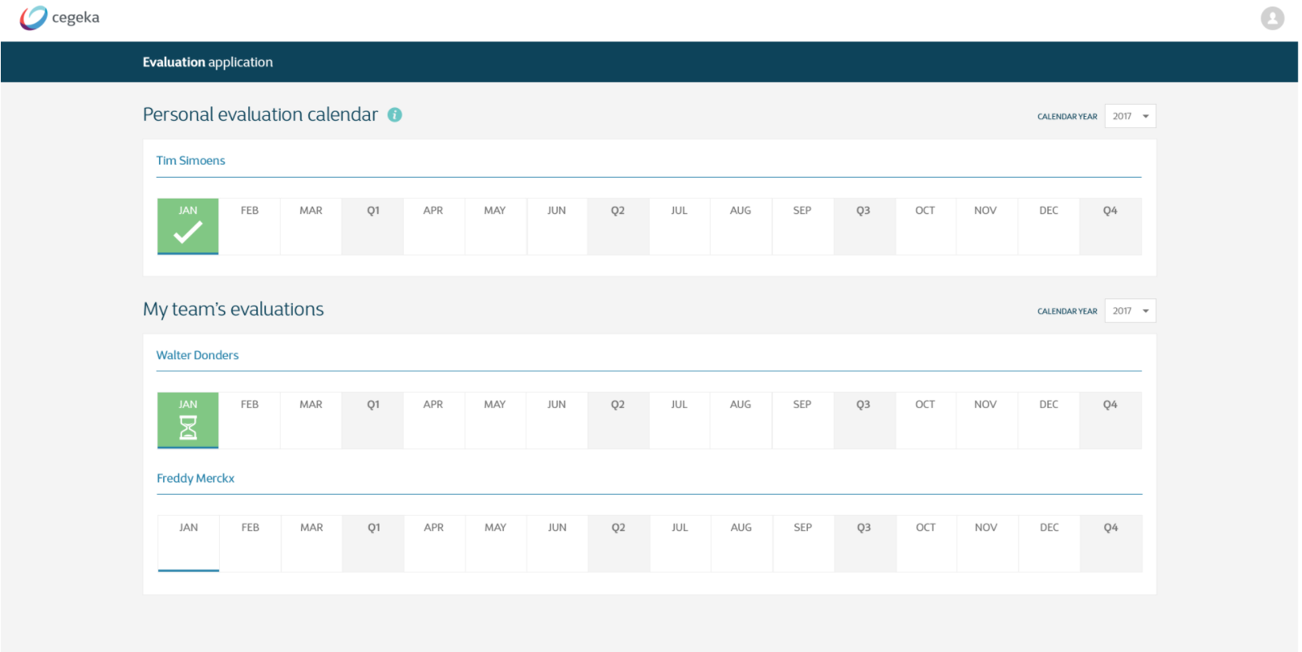

Portfolio manager view to be added

## **Technical description**

## **Acceptance criteria**

|  |  |  |
| --- | --- | --- |
| **Given** | **When** | **Then** |
| I (PM) am logged in | I open the tool | I see an overview page where my personal conversation moments are visible AND the moments with all team members (team based on AD) |
| I (portfolio manager) am logged in | I open the tool | I see an overview page where my personal conversation moments are visible AND the moments with all PMs (based on AD) |
| I (PM + portfolio) am on my overview page | I click on a ‘month button’ that doesn’t have a moment added to it. | The button turns yellow and the symbol used is the hourglass to show that one person has indicated that a moment has taken place and it waiting for the confirmation by the other one (See [US 05](https://docs.google.com/document/d/1lAFfW-Pwmuzdy1BtblSqp5D8BtJUvMNtqmfvejf-zMY/edit) to have an overview of all scenarios regarding colors/symbols) |
| I (PM + portfolio) am on my overview page | I click on a ‘month button’ of a team members that doesn’t have a moment added to it (so no indication by the member either). | The button turns yellow and the symbol used is the hourglass to show that one person has indicated that a moment has taken place and it waiting for the confirmation by the other one (See [US 05](https://docs.google.com/document/d/1lAFfW-Pwmuzdy1BtblSqp5D8BtJUvMNtqmfvejf-zMY/edit) to have an overview of all scenarios regarding colors/symbols) |
| I have added a conversation moment and confirmed it (in the window) | I refresh the page | The moment is still visible in the overview |
| I (PM + portfolio) am on my overview page | I click on a ‘month button’ of a team members that does have a moment added to it (added by myself). | The button turns grey again, without a symbol added, to show that no moment has taken place |